|  |  |  |  |
| --- | --- | --- | --- |
| Voltaje de la Fuente V (V) | Voltaje en la resistencia  Ro | | |
| 3.3 V | 5.1 V | 9.0 V |
| 3.0 | 0.8474V | 1.3634V | 2.28V |
| 4.0 | 1.09V | 1.828V | 3.06V |
| 5.0 | 1.42V | 2.28V | 3.8V |
| 6.0 | 1.688V | 2.72V | 4.45V |
| 7.0 | 1.95V | 3.172V | 5.31V |
| 8.0 | 2.219V | 3.6404V | 6.031V |
| 9.0 | 2.469V | 4.07V | 6.751V |
| 10.0 | 2.692V | 4.52V | 7.52V |
| 11.0 | 2.892V | 4.997V | 8.279V |
| 12.0 | 3.05V | 5.128V | 9.024V |
| 13.0 | 3.193V | 5.093V | 9.246V |
| 14.0 | 3.313V | 5.140V | 9.792V |
| 15.0 | 3.39V | 5.376V | 10.132V |

|  |  |  |
| --- | --- | --- |
| Voltaje de la Fuente  𝑉𝑖𝑛 (V) | Voltaje en la resistencia 𝑅𝐿 | |
| LM7805 | LM7812 |
| 3.0 |  |  |
| 4.0 |  |  |
| 5.0 |  |  |
| 6.0 |  |  |
| 7.0 |  |  |
| 8.0 |  |  |
| 9.0 |  |  |
| 10.0 |  |  |
| 11.0 |  |  |
| 12.0 |  |  |
| 13.0 |  |  |
| 14.0 |  |  |
| 15.0 |  |  |
| 16.0 |  |  |

|  |  |  |
| --- | --- | --- |
| Voltaje de la Fuente  𝑉𝑖𝑛 (V) | Voltaje en la resistencia 𝑅𝐿 | |
| LM7905 | LM7912 |
| 3.0 |  |  |
| 4.0 |  |  |
| 5.0 |  |  |
| 6.0 |  |  |
| 7.0 |  |  |
| 8.0 |  |  |
| 9.0 |  |  |
| 10.0 |  |  |
| 11.0 |  |  |
| 12.0 |  |  |
| 13.0 |  |  |
| 14.0 |  |  |
| 15.0 |  |  |
| 16.0 |  |  |

## Regulador de voltaje variable positivo

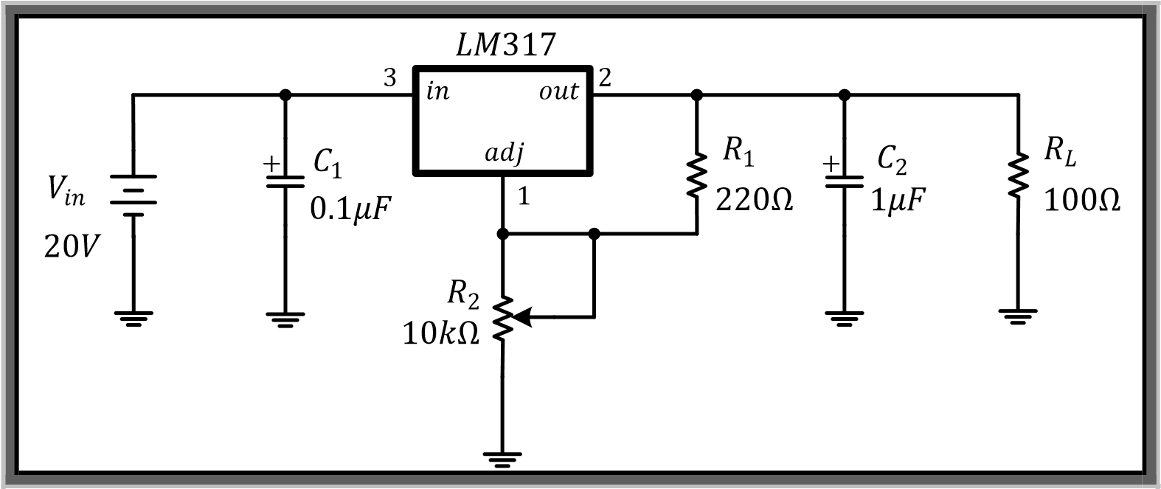

Variar el potenciómetro R2 para obtener el voltaje de salida positivo mínimo y máximo de la fuente.

V0max = _________ y V0min = ____________

## Regulador de voltaje variable negativo

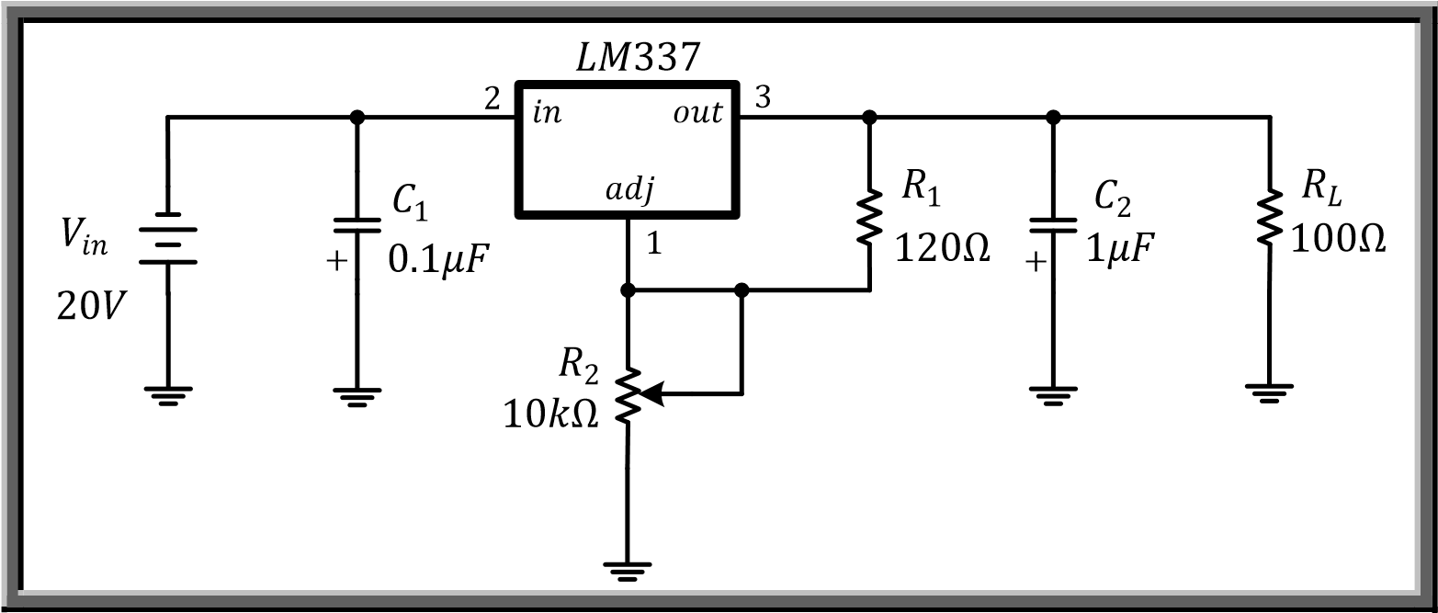

Ahora variar el potenciómetro R2 para obtener el voltaje de salida negativa mínimo y máximo de la fuente.

V0max = _________ y V0min = _____________